**IT304** Lab Report **LAB-2**

Date-August 30,2022

Name-Divya Kirtikumar Patel

Student ID-202001420

Lab Group- 6

**[2] The Basic HTTP GET/response interaction**

Questions:

Q1. Is your browser running HTTP version 1.0 or 1.1? What version of HTTP is the server running?

Both my browser and server are running on HTTP version 1.1.

Server: 1.1 Host: 1.1

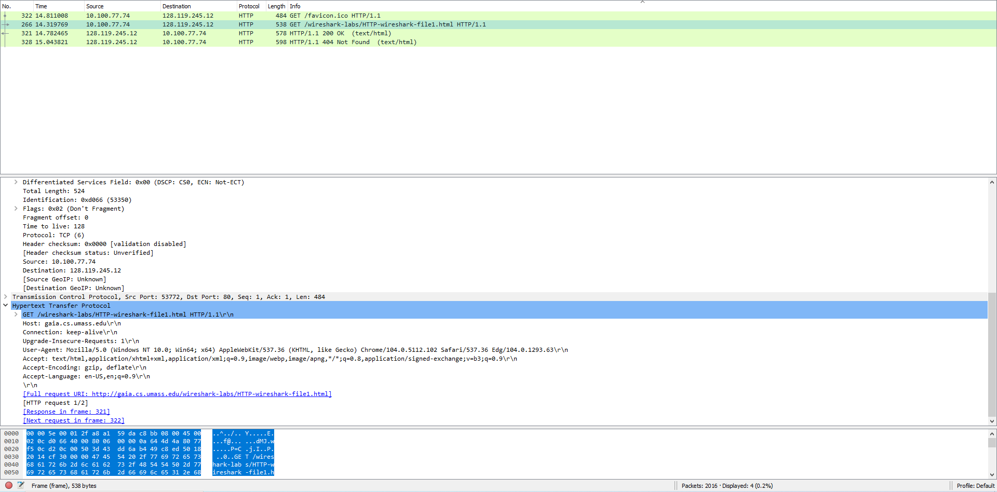

202001420_Divya_Patel

Q2. What languages (if any) does your browser indicate that it can accept to

the server?

Accept – language to the server : en-US

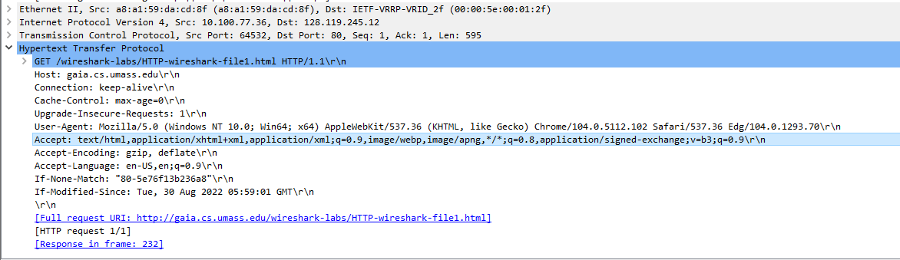

202001420_Divya_Patel

Q3. What is the IP address of your computer? and the gaia.cs.umass.eduServer?

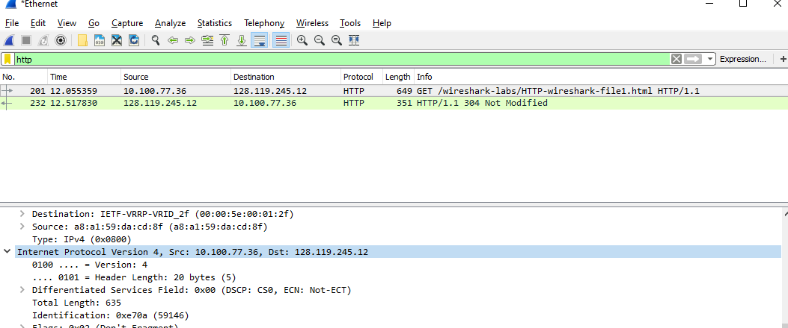

202001420_Divya_Patel

Internet Protocol Version 4, Src: 10.100.77.36, Dst: 128.119.245.12

Q4. What is the status code returned from the server to your browser?

Status Code: 200  
Response Phrase: OK

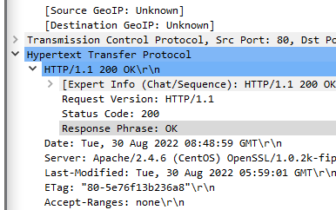

202001420_Divya_Patel

Q5. When was the HTML file that you are retrieving last modified at the

Server?

Last – Modified: Tue, 30 Aug 2022 05:59:01 GMT (At the server)

202001420_Divya_Patel

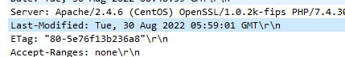

Q6. How many bytes of content are being returned to your browser?

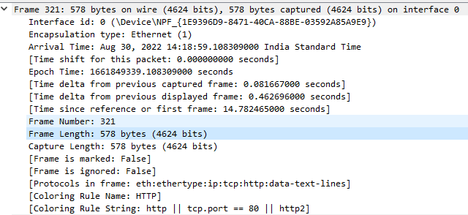

202001420_Divya_Patel

**[3] The HTTP CONDITIONAL GET/response interaction**

Questions:

Q1. Inspect the contents of the first HTTP GET request from your browser to the server. Do you see an ”IF-MODIFIED-SINCE” line in the HTTP GET?

No, I don’t see an ”IF-MODIFIED-SINCE” line in the HTTP GET.

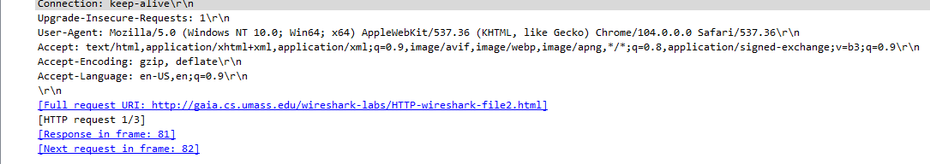

202001420_Divya_Patel

Q2. Inspect the contents of the server response. Did the server explicitly return the contents of the file? How can you tell?

Yes. As we can see the content returned by server in *Line-based text data* field.

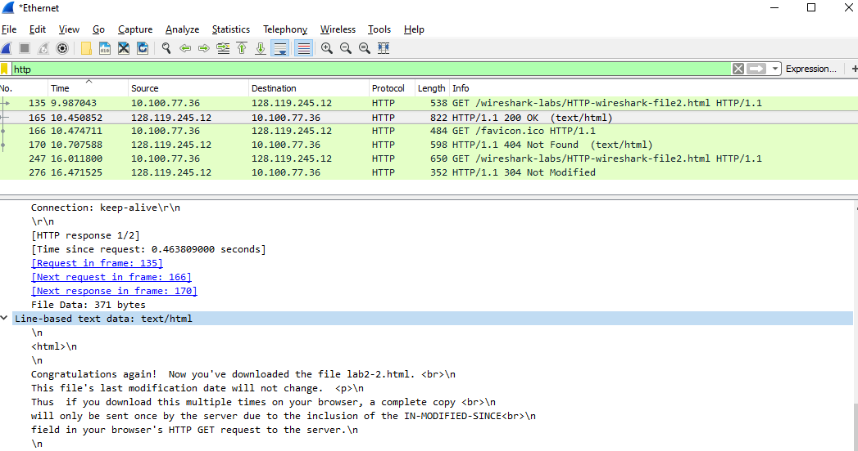

202001420_Divya_Patel

Q3. Now inspect the contents of the second HTTP GET request from your

browser to the server. Do you see an ”IF-MODIFIED-SINCE:” line in the HTTP GET? If so, what information follows the ”IF-MODIFIED-SINCE:” header?

If-Modified-Since: Tue, 30 Aug 2022 05:59:01 GMT\r\n (the timestamps is the information following the header)

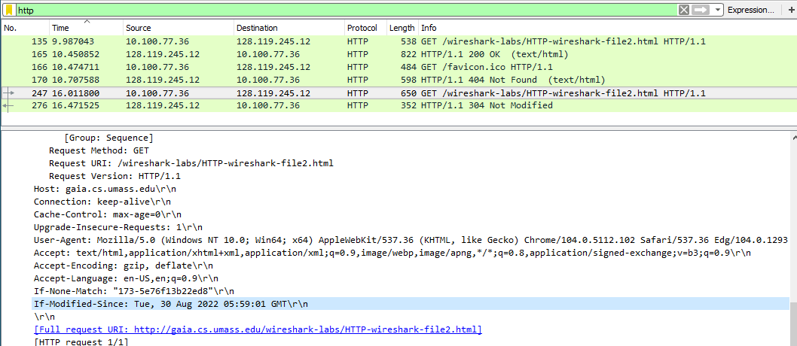

202001420_Divya_Patel

Q4. What is the HTTP status code and phrase returned from the server in response to this second HTTP GET? Did the server explicitly return the contents of the file? Explain.

Status Code: 304

Response Phrase: Not Modified

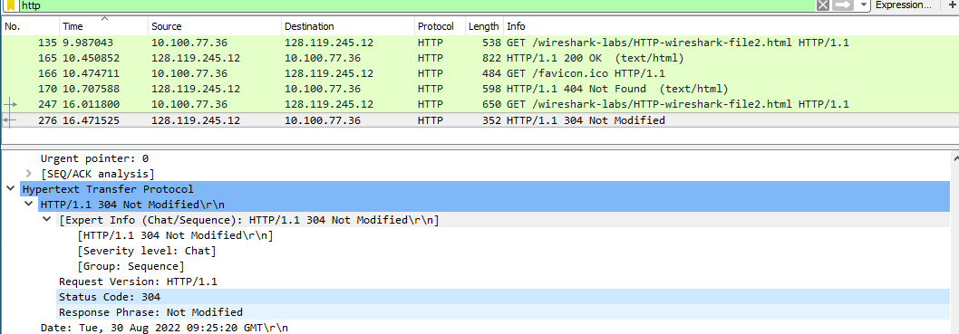No, the server didn’t return the contents of the file.

202001420_Divya_Patel

**[4] Retrieving Long Documents**

Questions:

Q1. How many HTTP GET request messages were sent by your browser?

2 HTTP GET request messages were sent.

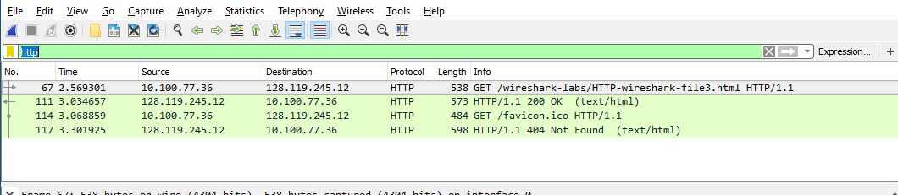

202001420_Divya_Patel

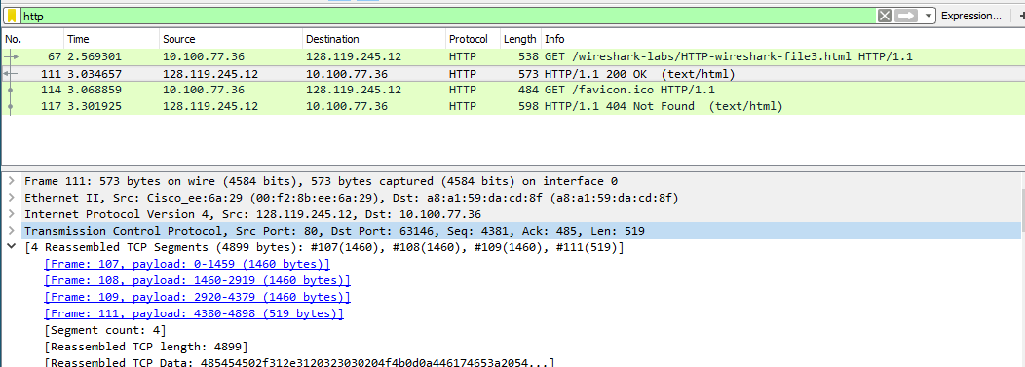Q2. How many data-containing TCP segments were needed to carry the single HTTP response?

202001420_Divya_Patel

Four data-containing TCP segments were needed.

Q3. What is the status code and phrase associated with the response to the HTTP GET request?

Status Code: 200

Response Phrase: OK

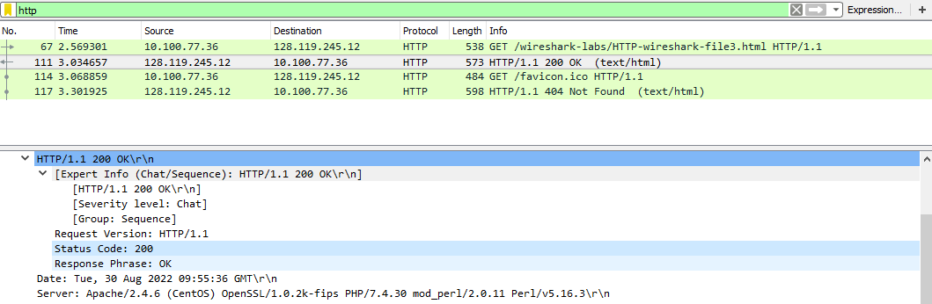

202001420_Divya_Patel

**[5] HTML Documents with Embedded Objects**

Questions:

Q1. How many HTTP GET request messages were sent by your browser? To which Internet addresses were these GET requests sent?

Destination: 128.119.245.12

Destination: 128.119.245.12

Destination: 178.79.137.164

202001420_Divya_Patel

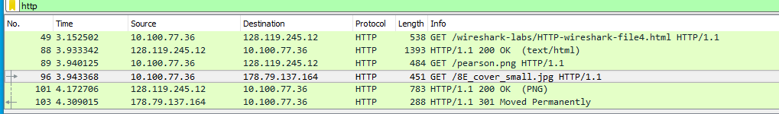

Q2. Can you tell whether your browser downloaded the two images serially, or

whether they were downloaded from the two websites in parallel? Explain.

The images were downloaded serially. This is confirmed in two ways.

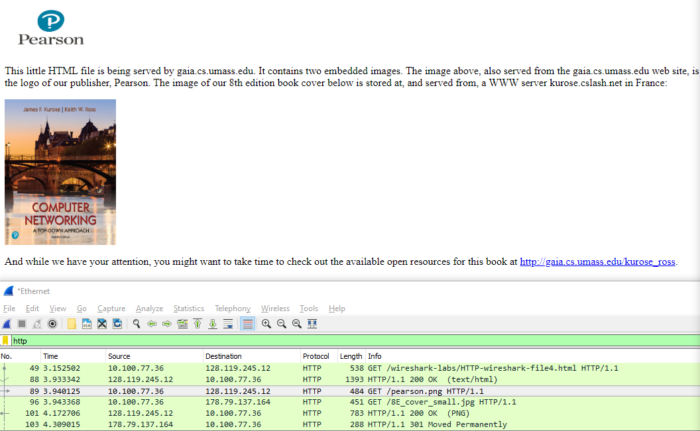The timestamp for both GET requests is different and the Stream Index is also different for both the requests.

202001420_Divya_Patel

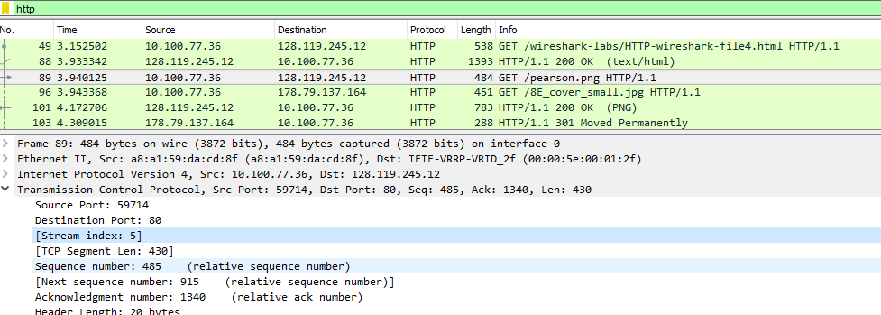

202001420_Divya_Patel

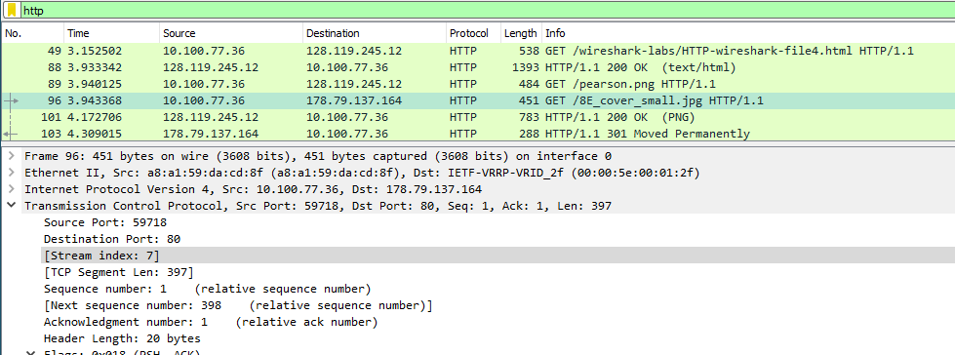

202001420_Divya_Patel

**[6] HTTP Authentication**

Questions:

Q1. What is the servers response (status code and phrase) in response to the

initial HTTP GET message from your browser?

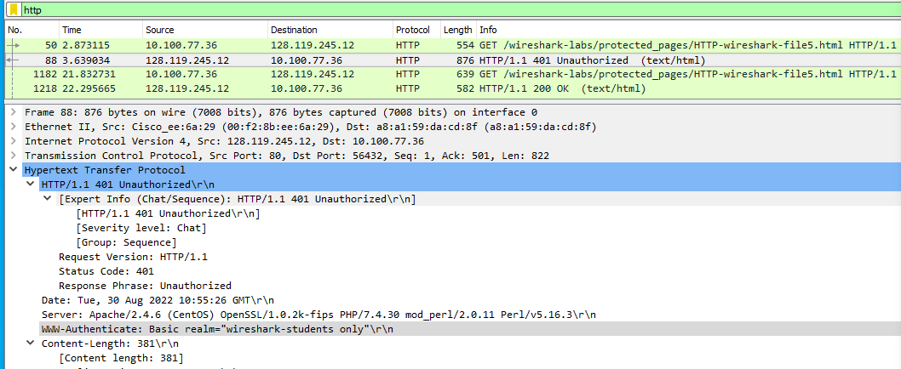

202001420_Divya_Patel

Status Code: 401

Response Phrase: Unauthorized

Q2. When your browsers sends the HTTP GET message for the second time,

what new field is included in the HTTP GET message?

First Request --   
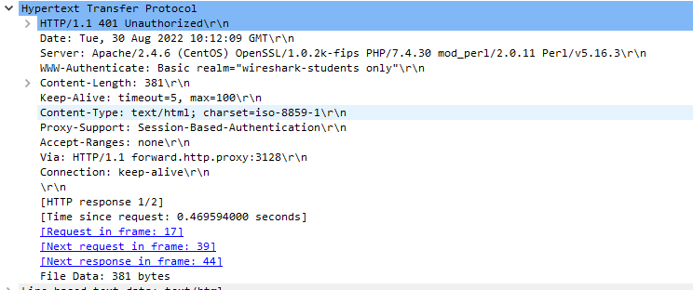  
  
Second Request --  
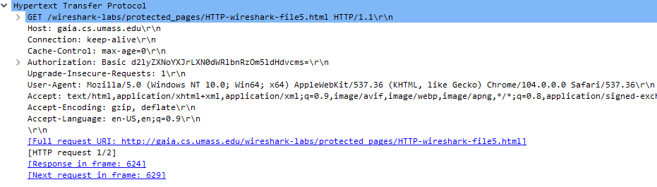

202001420_Divya_Patel

202001420_Divya_Patel